Player Bios:

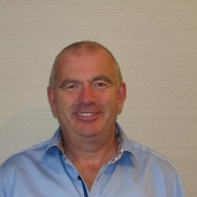**Name:** Jeremy Stephenson

**Nickname**: Jem

**What’s In the bag** – usually his ‘lost’ glasses and phone.

**Most memorable CRAP moment** – Involved a mix-up at a nightclub and a taxi home,

Jem is the Gravies captain and a stalwart of the ‘CRAP’ tours with over 20 campaigns both at home and abroad. He is an inspirational leader both at the bar and away from it. Never shirks his drinking and eating responsibilities to ensure that morale of the team is always high. A northerner at heart he follows Carlisle United Football Club

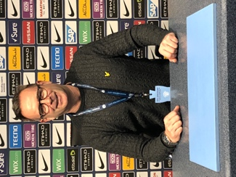**Name:** Dave Worrall

**Nickname**: Wozza

**What’s In the bag** – A lot of balls with indicators and clubs that go left (and then left again)

**Most memorable CRAP moment** – Involved a buggy and Batch’s car

Dave is a Gravy boy with over 15 years CRAP experience. The only RC player to date to get a hole in one whilst on tour. Often found supporting the Captain at the bar and playing Cribbage against the ‘Chuckle Brothers’. A true northerner he follows Manchester City Football Club.

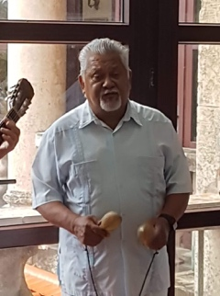

**Name:** Dave Kay

**Nickname**: Nicest Man in the Club

**What’s In the bag** – about 6 putters

**Most memorable CRAP moment** – Creator of the Northern Survival kit for the Softies

Dave is a Gravy boy with over 5 years CRAP experience. Dave is steady away and can be relied upon to be down the middle on most fairways. A lover of all things football he follows Blackpool Football Club. He is a lovely man, hence his nickname.

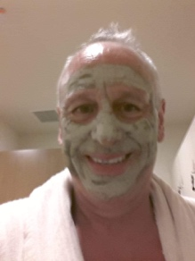

**Name:** Tom Rowles

**Nickname**: Tugboat

**What’s In the bag** –Jem’s cast offs

**Most memorable CRAP moment** – Rookie year – but watch out for his WhatsApp messages!

Tommy ‘tugboat’ is the latest member of the Gravy Squad, a member at the exclusive Poulton Golf Club and Jem’s doubles partner (when Dom Harrop is ill). TT is the rookie that we will all be keeping an eye on, the grapevine has been saying that he has a new driver and has had golf lessons…..not sure he will fit in! His redeeming feature is his drinking ability, the primary reason he was drafted in.

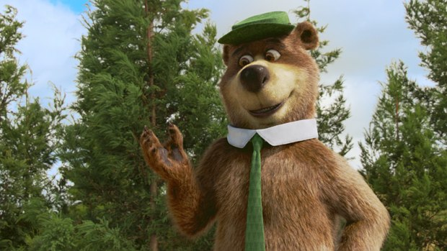**Name:** John Goodwin

**Nickname**: The Bear

**What’s In the bag** – His ‘society’ 14 handicap certificate and a box of Sugar Puffs

**Most memorable CRAP moment** – having the ‘Bear Licence’ named after him but more impressive was noticing Kelly Brook had turned up at the Seiners Arms to see us all.

John is one of the few who has made the brave decision to front off against ‘family’. Being one of the Blake clan he has always been a true northerner and the black sheep. John always produces great golf and often partners his good friend ‘Constable Els’. John is a plastic northerner who supports Tottenham Hotspurs. His golfing friends often call him the postman because ‘he always delivers’. Always entrusted to hold the ‘kitty’

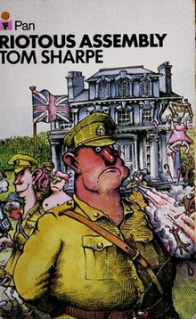

**Name:** Graham Bayliss

**Nickname**: Constable Els (or just Els to his friends)

**What’s In the bag** – the golden wedge

**Most memorable CRAP moment** – involves a “2 reel” fruit machine impression

Constable Els is a man mountain, a ‘gentle giant’ who was born in South Africa. Mr consistent he isn’t, but the boy can play some wonderful golf and has racked up memorable scalps in previous Ryder Craps. An honorary Northern Boy who always has a matching outfit on a Saturday with the Bear.

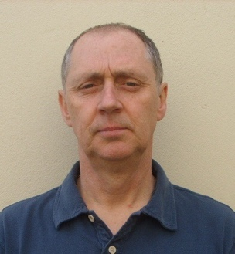**Name:** Martin Pickering

**Nickname**: Roland

**What’s In the bag** – Cheese

**Most memorable CRAP moment** – Beating James Blake in the RC Singles

Martin hails from the most northern Gravy outpost. His hometown of Hartlepool is most famous for hanging monkeys. Martin has come on leaps and bounds with his golfing skills since joining the Gravy ranks many years ago. Unlike Els he isn’t a ‘man mountain’ but he possesses skill and guile on the golf course and his ‘rat like’ appearance instils fear into most opponents.

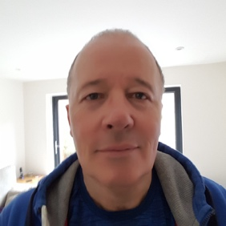**Name:** Harvey Harrington

**Nickname**: Harvey aka Fat Bastard

**What’s In the bag** – usually food and lots of it.

**Most memorable CRAP moment** – losing Richard’s shoes

Harvey is Richards chauffer and golfing companion at home but like the Bear has made a brave decision to break ranks and join the Northern `gravy contingent. His heritage is deeply embedded in the northern wilds of Scotland so that explains the desertion. He flip-flops across teams to try and ensure a ’Win’ but he is now a true Gravy and will no longer consider the turncoat approach of previous years.

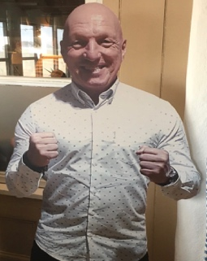

**Name:** Colin Welsby

**Nickname**: Loco

**What’s In the bag** – Nothing, He’s a cardboard cut out

**Most memorable CRAP moment** – not going but sending a cardboard replacement

Cardboard Loco is the Gravy Boys 9th Man, I say, I say, the Gravy Boys 9th Man. He can be heard at breakfast giving updates from the previous days play and wishing good cheer to all the players, especially his special friend Harvey. He is Blakey’s long lost son, I say I say long lost son. Sadly missed by the Gravy boys but due to his commitments in the construction industry can’t make this years’ Ryder Crap